BSc (Hons) Computing Course 2018/19
Level 6 Production Project
Name: Anup pokhrel | Student I.D.: c7193454
Course: BSc (Hons) Computing | Supervisor’s Name:  Pranita Upadhyaya
FINAL PROJECT INDIVIDUAL AIM & OBJECTIVES
Title of my Project:
Online Examination system

Aim of my Final Project:
Aim of the project is to develop a web-based application that helps to take an online exam of student

Objectives of my Final Project:
- To do research and explore about the Education and Examination system of Nepal.
- To design a responsive web-application.
- To develop online examination system
- To test a different functionality of the system.
- To make the examination system more effective and increase the efficiency.
- To saves people money and time.
- To learn about the problems in traditional examination system
- To document a project report in structured way.

Specification of my Final Product:
The Site will have these Moscow specifications;
Must have
- Responsive and user-friendly design
- User registration, login and logout
- Proper validation of registration form
- Admin Panel
- Add, delete view questions
- Selection of subject
- Selection of answers
- Marking of answer
- Ranking of student
- Negative marking for wrong answer
- Publishing result

Should have

- Random selection of questions
- Random distribution of question
- Timer
- Proper validation in selection of answer
- Multiple instructor function

Could have
- Subjective questions examination
- Tracking time that student take for each question
- Re-setting password
- Proper search functions

Research

Research title= Online Exams: Practical Implications and Future Directions
Outline of my research

Research should be done in various field for this project. We should research on how the operation of exam system should run. We should focus on its efficiency and effectiveness. It is a web-based application so, we should focus on its responsiveness, easy user control, navigation and easy surfing.
After research it was found that a good database system in essential to make the project successful. MYSQLI is the suitable database server for this project. PHP programming language is very useful to developed a web-application because it supports MYSQL database

Methods of Production Evaluation

A description of the method of product evaluation (100 words max).

Expert analysis evaluation method is used in this project to evaluate the product. Expert is directly involved in this project to give suggestion and feedback. Expert helps to test the usability, performance, consistency, cost of the product based on heuristics evaluation technique. It provides the speedy feedback to the developers and designers. It helps to maintain errors and keep the standard of the product. Expert evaluates system based on a cognitive principal. It helps to find out the bugs in the user interface and to find out the usability errors in the system. Expert is directly involved in the project so; they know about the internal functionality of whole systems. They help us to develop a proper well functional system by using optimized code.

Project Planning
A one-page Gantt chart showing timing of different phase of project

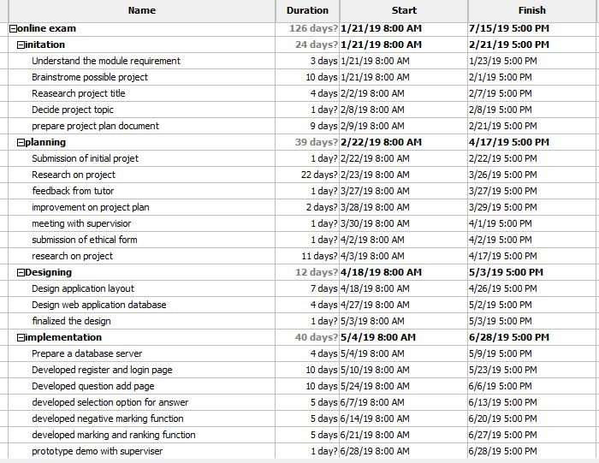
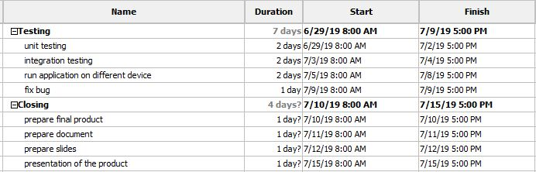

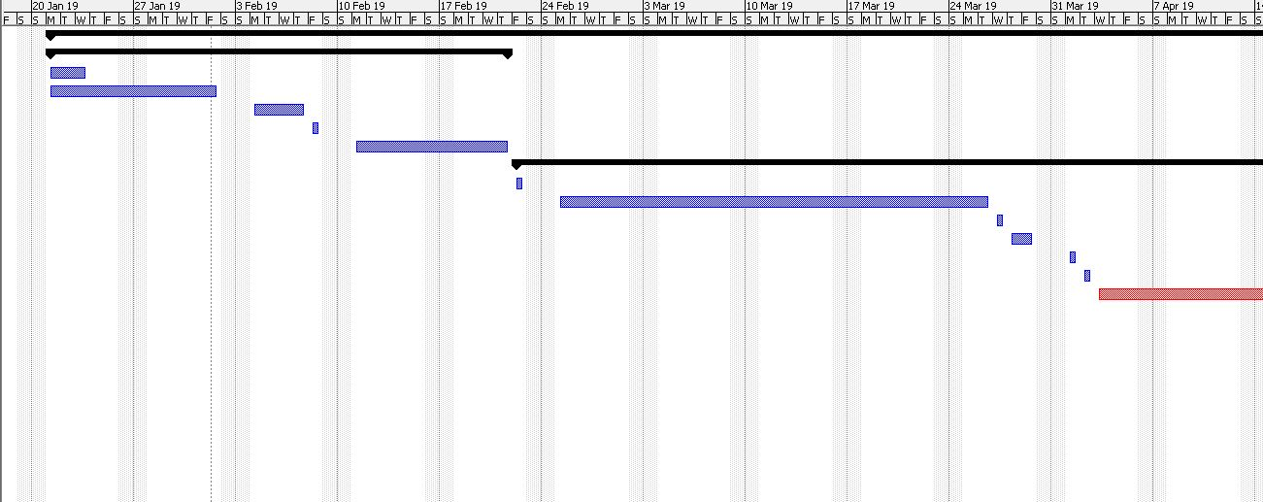
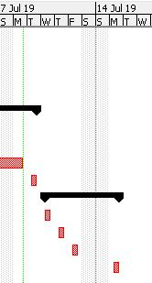

Methodology
Which Methodology you are planning to follow and why? Give description. (such as waterfall, agile development methodology etc.)

Agile Development Methodology is followed in this project because this methodology is iterative, efficient and flexible. It provides a good customer satisfaction and collaboration with the customer. Chances of project failure is very low in this development methodology. It helps to develop the product in given time. Agile allows the changes in project in any time as user required. In this methodology product is delivered in a multiples phase to the user in different interval of time. It helps to get feedback from customers time and again. Agile helps to estimate the total cost and time required for the project. It helps to carry out the progress speed of each development team.

PHYSICAL RESOURCE
The hardware and software I require to complete my Project successfully:
Item (Hardware or Software) |  | Source (Faculty, own or specified another organisation)
- Dell Laptop |  | OWN
- (Sublime text editor) |  | OWN
- Xampp |  | OWN
- Microsoft package |  | OWN
- Project libre |  | own

HUMAN RESOURCE
I am working on my Project with the following people [list any others involved including your client, your supervisor (not known at the time you submit your Initial Project Plan), those supplying ideas, feedback or evaluation, users of your product, other students (if you are in a team). Delete or add rows as necessary].

Name 1:  Dr pranita upadhyaya | Role: Module Leader
The British College Staff | Role: Module Leader
INITIAL BIBLIOGRAPHY
[Include a list, in Leeds Beckett Harvard format, of 10 authoritative references which can later form the basis of your literature review. You can include more sources if you like to help justify the project and product specification. Remember to cite references from the main body of the project plan, where appropriate. For a guide to the correct format to use see -]

https://www.ittrainingnepal.com/php-project/online-examination-system/

https://www.phptpoint.com/projects/online-examination/

https://www.thinkexam.com/

https://www.academia.edu/6729977/Online_Examination_System_because_examination_matters_Name_ALLAN_THATHI_NJERU

https://www.scientific.net

https://www.ukessays.com/essays/computer-science/overview-on-developing-an-online-examination-system-computer-science-essay.php

http://www.ijrcee.org/index.php/ijrcee/article/view/225

https://www.slideshare.net/fiu025/online-examination

https://www.hcibook.com/e3-docs/slides/notes-pdf/e3-chap-09-6up.pdf/

https://skillsforlearning.leedsbeckett.ac.uk/local/academic_communication/harvard_referencing/index.shtml/

